Required Practical Activity: Determining an Unknown Concentration by Titration

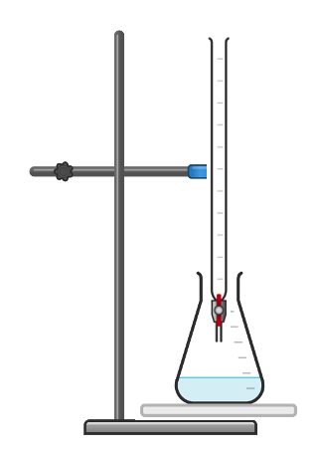
Apparatus:
- 25 cm³ volumetric pipette
- Pipette filler
- 50 cm³ burette
- 250 cm³ conical flask
- Funnel
- Clamp stand and clamp
- White tile

Chemicals:
- 0.1 mol/dm³ sodium hydroxide solution (irritant)
- ‘Unknown concentration’ sulfuric acid
- Phenolphthalein indicator

Method:
- Clamp the burette to the retort stand with enough space beneath for the conical flask and white tile.
- Check that the burette tap is closed, then use the funnel to help pour in sulfuric acid past the 0.00 cm³ line. Remove the funnel.
- Put the bottle of sulfuric acid beneath the burette and slowly open the tap until the bottom of the meniscus of the sulfuric acid reaches the 0.00 cm³ line.
- Add 25 cm³ of sodium hydroxide solution to the conical flask using the volumetric pipette and pipette filler.
- Add 5-10 drops of phenolphthalein indicator to the sodium hydroxide in the conical flask. Gently swirl the flask and the contents will turn pink.
- Place the conical flask on a white tile beneath the burette.
- Slowly and carefully open the burette’s tap to allow approximately 10 cm³ of sulfuric acid into the conical flask, constantly swirling the conical flask the entire time.
- Close the tap a little so the sulfuric acid enters the conical flask a drip at a time. Eventually, one of these drips will cause the colour a colour change from pink to clear. At this point, immediately shut the tap so no more sulfuric acid is added.
- Read the level of the sulfuric acid in the burette from the bottom of the meniscus and record this on your table.
- Repeat the experiment two more times and complete your table. Calculate the mean volume of sulfuric acid needed to neutralise 25 cm³ of 0.1 mol/dm³ sodium hydroxide.

Results:
Record your results in the following table.

Titre | 1 | 2 | 3 | 4 | 5 | Mean
Volume of acid needed to neutralise alkali (cm³)

Identify concordant results (results that are within 0.2 cm³ of each other) and use these to calculate the mean volume of acid needed to neutralise the alkali.

